**Lab Manual 4 Class work**

**Q1**

//using header file iostream

#include<iostream>

using namespace std;

int main() {

int sum=0;

//sum of first ten natural numbers

for (int i=1;i<=10;++i){

sum=sum+i;

}

cout<<"Sum of first ten natural numbers:"<<sum<<endl;

return 0;

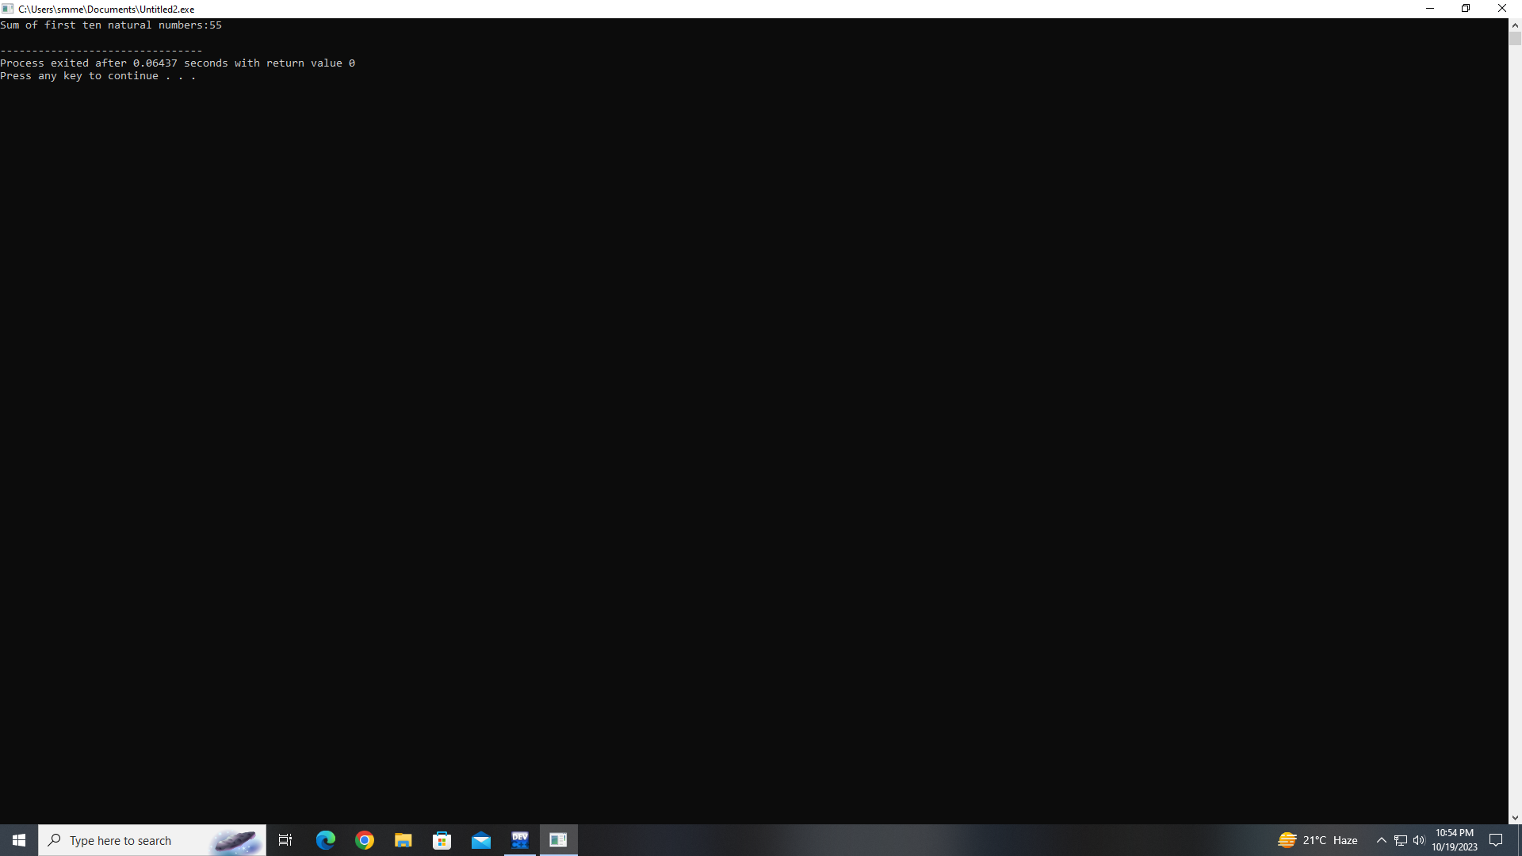

**Q2**

#include<iostream>

using namespace std

;int main(){

int number=2;

int limit=10

//print the table

;cout<<"Table of"<<number<<":\n";

for (int i=1;i<=limit;++i){

cout<<number<<"*"<<i<<"="<<

(number*i)<<endl;

}

return 0;

}

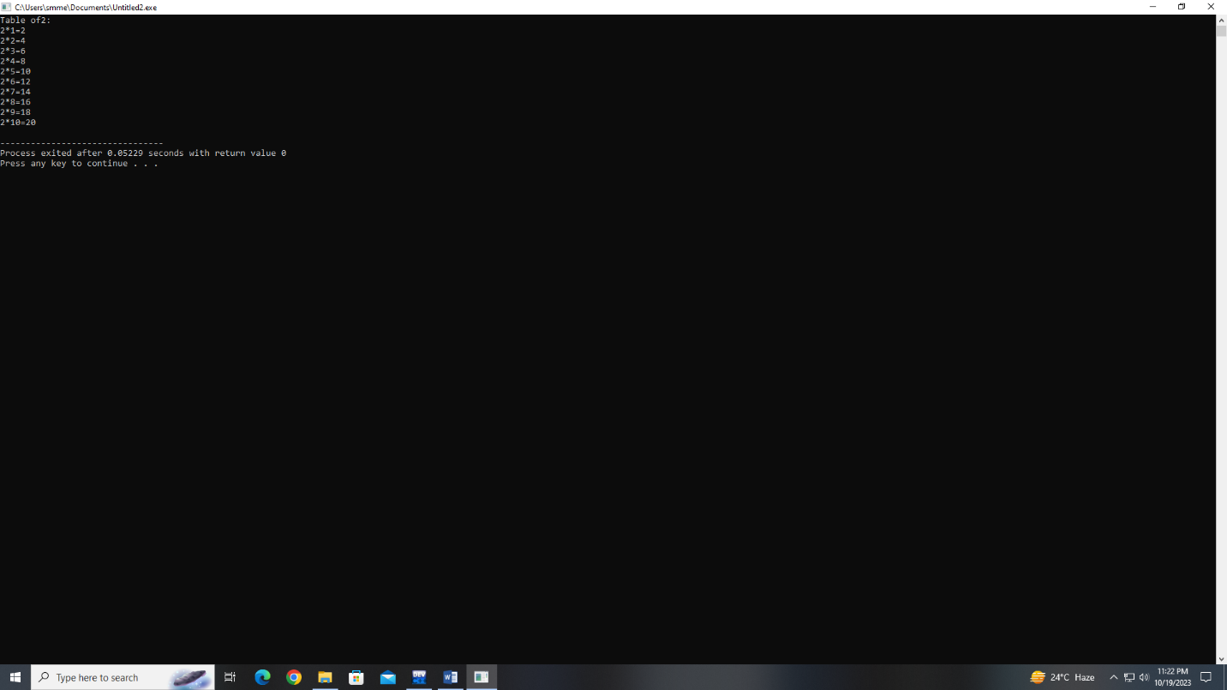

**Q3**

#include<iostream>

int main() {

int number;

int factorial =1;

//ask user to enter number

std::cout<<"Enter a number:";

std::cin>>number;

for (int i=1;i<=number;++i) {

factorial=factorial*i;

}

std::cout<<"Factorial of"<<number<<"is:"<<factorial<<std::endl;

return 0;

}

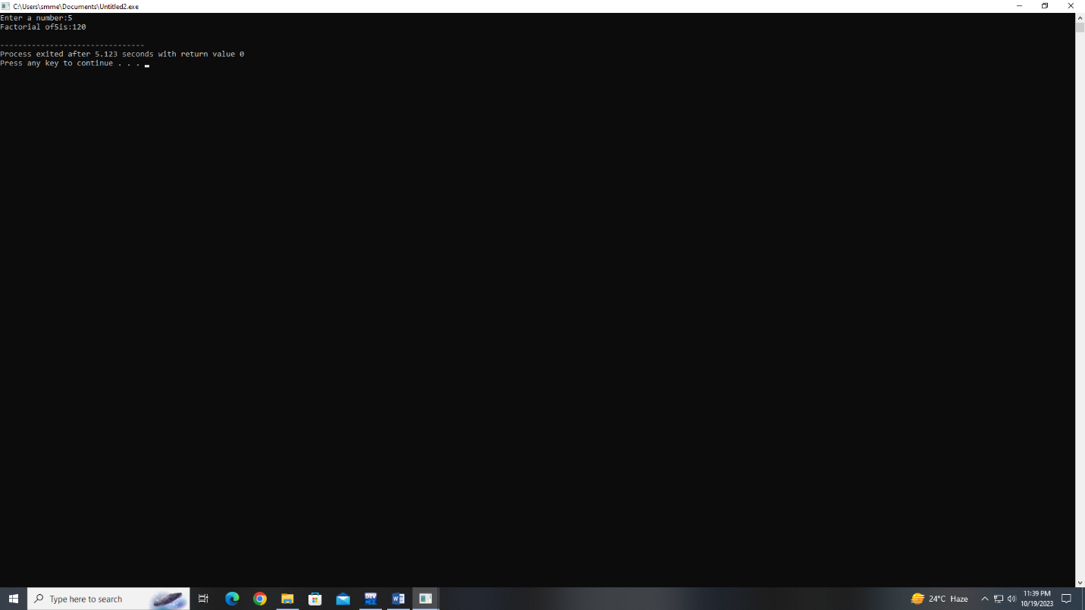

**Q4**

#include<iostream>

int main() {

int limit,firstTerm =0,secondTerm = 1,nextterm;

//ask to write limit

std::cout<<"ENTER THE LIMIT:",

std::cin>>limit;

<<limit<<":\n"

while(firstTerm<=limit){

std::cout<<firstTerm<<"";

//calculate next term

nextTerm=firstTerm+secondTerm

firstTerm=secondTerm

secondTerm=firstTerm

}

std::cout<<std::end;

return 0;

}